Widgets Website Data Report

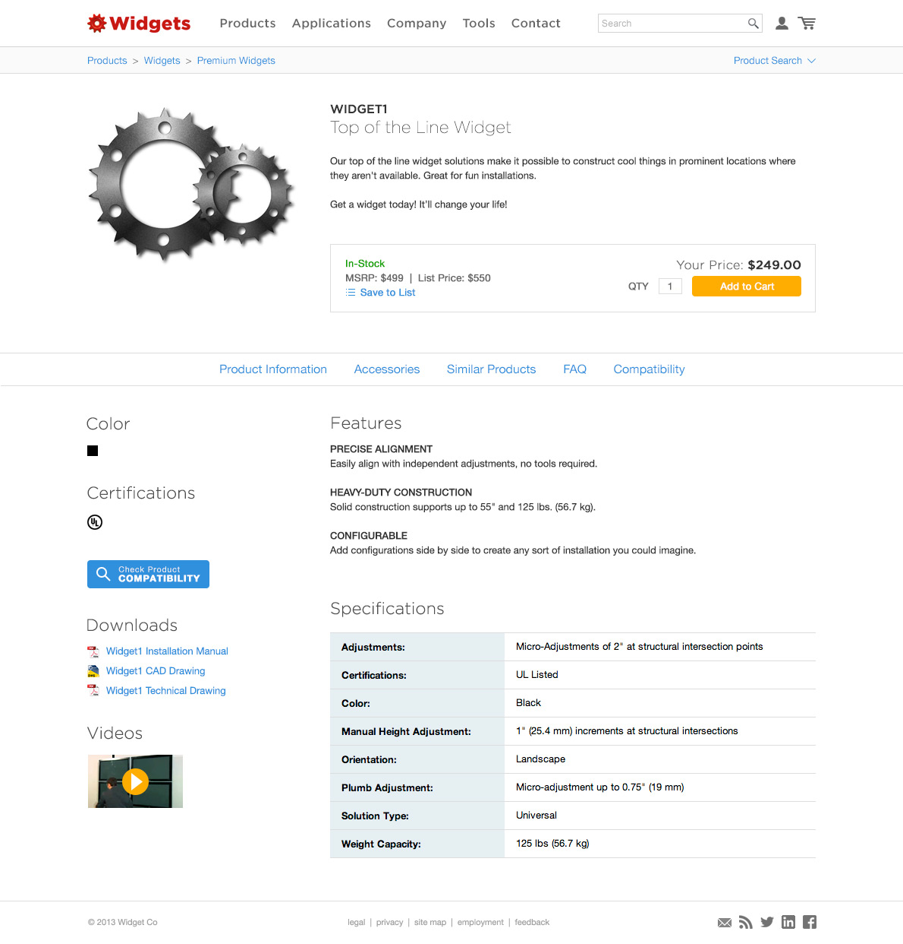

Prepared by
Kyle Larson - 8/15/2013

Summary

Purpose
The goal of this research is to give us a source of solid data to use when making project decisions for the website in 2013. We should use this data to inform our decisions (especially when the data is overwhelming), but not as a strict guide to our activities. Much of the data & suggestions can point to an issue but not the best solution.

Method
This data was gathered from three primary sources: User testing during Jan 2013, Google Analytics data from Jan 2012 – Jan – 2013 and a user feedback form sent out via email, social media, and our website.

Findings
Our user survey showed a very positive view of the website, but there were a number of suggestions for improvement. The main things we can do to improve are offering a pricing feature, adding simplicity and clarity to the site (design & content), improving search, and increasing the discoverability of accessories.

Implementation
The data here is a collection of everything discovered, not a to-do list of the items we will be implementing. Our next step will be turning this data into a list of potential projects and meeting with the team to determine priority.

I believe for the majority of these items we should use an iterative process for implementation (rather than a full relaunch) with an end goal in mind. This will avoid negatively impacting our users, as the majority of them believe our current site is very good. During this process we can implement an A/B testing tool such as optimizely.com for testing out content changes.

Testing

Overview of Testing Results

We saw that most tasks on our site were easy for our users to accomplish, but did discover that there were a number of places where we could speed up the process for our users and improve the flow in some places.

Key Design Items

We need to continue to improve the clarity of our site, removing/hiding unnecessary features and getting users to their goal more quickly. The large number of options presented on the site confuses our users.

Key Development Items

We discovered some minor functionality fixes that will improve the user experience such as adding cookies for search choices and removing unnecessary items.

Key Content Items

Accessories are causing issues on the site. This requires effort between all parties (design, development, content) to link them at a product level. Our descriptions on the site are not clear. We need the short descriptions to clearly separate products by their key differences. Users spend a lot of time figuring this out and often need to call customer service.

New Features

Users would like us to improve the discoverability of accessories leading to finding full solutions.

Testing Outcomes

Code Fixes
- Set cookie for # of products displayed in results list (list more) (x2)
- Prevent filters from clearing when going back/forth
- Switch category names for easier sorting
- When picking an item in auto-complete go directly there (no clicking search)
- When changing pages on search move back to the top
- Remove compatibility warning if user came from compatibility search
- ‘-‘ causes issues when searching

Site Design
- Add phone # to header/footer (x2)
- Make series/product pages look less similar
- Add search term to results page
- Ability to view a particular spec on search page
- List the parts each product comes with
- ‘Sticky’ vs hover on drop-downs

Content - Marketing/PM
- Accessories hard to find/not all on product pages (x15)
- Better product descriptions/explanations, what are the differences? (x5)

SURVEY

Overview of Survey Results

The majority of our customers found our website easy to use and that it was better than our competitors, but they had many suggestions on how we can continue to improve it.

Key Development Items

We need to work to improve our search functionality when we aren’t matching an exact model number.

Key Content Items

We need to limit our product options to lower confusion over which product to select. We can improve our materials by adding application photos and more product sell-sheets.

New Features

The most requested item is pricing on the website. User’s complained about having to go to a separate site to get their pricing. They’d also like to be able to create product lists and PDF/email them.

Who Responded – 208 People

Using Our Website

Best & Worst

Open-Ended Questions

How can we improve finding products?

General Consensus: it is much better than it used to be/works well

Code Fixes
- Search providing better/suggested results for keywords (x8)
- Expand/contract filter list (headers)
- Blank tabs are annoying, remove them
- Metric Conversions

New Features
- MSRP / Pricing (pricing should be the same site)(x20)
- Order/PDF creator from product list (x3)
- Steps for building out a project (accessory suggestion/builder) (x3)
- Drill down search (questions to find series)
- Similar/suggested products

Site Design
- Search has too many steps
- Hard to find ‘new’ products
- product details at a higher level

Content - Marketing/PM
- Accessories hard to find/not all on product pages (x15)
- Better product descriptions/explanations, what are the differences (x5)
- Shipping & Product weights (x5)
- Specs missing sometimes (x2)

How does it compare to competitor’s websites

- Make homepage simpler, no fluff
- Our descriptions are not as clear to choose between our products
- Other sites list their newest products
- Their country landing pages are annoying
- Our filtering is better

WEB STATISTICS
Finding Products

The search box is the most popular method of searching (66% to 34%) over drop-downs. This element should remain the most prominent feature of the website.

Most searches are for consumer product compatibility (70% to 30%). Add additional options when searching for compatibility.

Most users browse to find products (61% to 39%). Look for ways to improve browsing.

Browsing Products

Widget A is by far the most popular category with 46% of the total traffic.

Most users start browsing with a sub-category directly from the product menu.
Product Pages

Specifications & downloads are the most popular product content.

Banners & Links

Banners in the beginning 2 positions drastically out perform other banners, the first banner receives by far the most clicks. 1.5% of visits to the homepage resulted in a banner click.

News

Most users find the news stories through the links on our homepage. However news items only account for about 0.2% of the total traffic from the homepage.

News traffic is highest on Tuesdays. Weekdays, Monday – Thursday, are by far the most popular.
Other Pages

Suggestion: see if any items can be combined/moved around to simplify the menus based on usage.
Technology

The majority of our users are on a desktop or laptop, however the tablet and phone segments have been slowly growing.

Mobile traffic has been increasing steadily; up 49% since May.

Our most used device is the iPad followed by iPhone & Android phone (which are nearly tied). Other devices have a much smaller market share.

Most of our users are on iOS followed by Android. This is largely due to the adoption of the iPad amongst our users.

